Database System for Retail Sales Company

Sumanth kurapati

https://github.com/Sumanthkurapati/DB-PROJECTS/week1

10-Jul-2022

**Table of Contents**

About Business 3

Comparison with other business 3

Design of network architecture 3

Important types of data used in business 5

Usage of File formats 5

References 6

# About Business

The retail sales company is to sale the product or goods by a business to end user or customer either with an online or offline stores. The business which I have chosen is a large scale where it provides a goods to all over United States of America. All the products are manufactured from outside the country and sales is been distributed in USA. With the expansion, the business sells about food and other beverage products to customers based on the demands. Through this business, most of the customer can able to purchase necessary food product from the online retails shop. This also increases about sales profit of the organization and as well as customer service support regarding the food products.

# Comparison with other business

The similar business which I have compared towards my business is Walmart which is an American Multinational retail corporation locates on USA. This is one of the biggest retailer discount store which provides variety of products with high quality through a shopping experience. The products that are sold by the Walmart business is health and beauty aids, food and beverage products, hardware, electronic items and houseware products.

The annual revenue of Walmart for the year 2021 is about $559.151B. By comparing with the previous year, 6.72% has been increased. Business will operate maximum of 10,500 units in more than 20 countries. From the world wide, there are 2.2 million employees in the Walmart but about 1.6 million employee work in US alone.

Link: <https://www.macrotrends.net/stocks/charts/WMT/walmart/revenue>

The above link shows about the revenue of the Walmart business during the annual year 2021.

# Design of network architecture

Since the business is large, database architecture will helps in proper representation of database design. Based on the architecture, the database system components can be structured, modified, replaced and altered. For our business, three tire architecture is required which makes easier to manage the database effectively.

**About 3-tier architecture**

For the food and beverage product retail business, 3-tier architecture system has been proposed. This is also known as client server architecture which makes the business development and maintenance process more independently. The architecture will also have a separate modules to process the data and store the information in the server. Architecture contains

Presentation layer – this layer runs on the client where the user uses PC, mobile or tablet to communicate with the server or database.

Application layer – application layer is an intermediator where the user and the database management system where the communication is carried based in user request. Based on the request, the response from the DBMS will be delivered to the user. This layer is also responsible for processing functional data and rules before the data is been progressed to the user.

Database – database will able to store all the information regarding the business process. From the user request, the data can be required by using query languages.

Yes, the database need to be distributed for the business because it helps in locating the all the information in various location. By the distributed database,

* Reliability can be achieved because there will be no effect on performance if system get failed.
* Data can be recovered easily from the different location DDBMS.
* Can able to achieve a better response from the server or database when processing with the queries
* Requires minimum cost to use, communicate and manipulate the data in the DDBMS

**Client-Server Design**

The client server network design for the business is shown in below diagram.

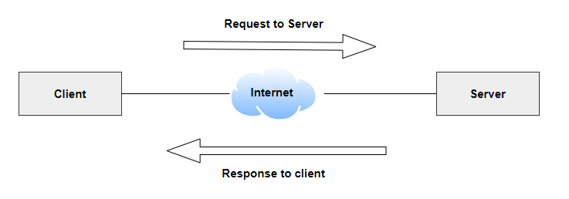

***Fig1: Client-Server Model***

From the above diagram, client is represented as a user or the host where it is capable of receiving information from the service providers. Server is an intermediator where it provide some information related to the service which is requested. All the process are made through a HTTP or HTTPS request and response.

Advantages of using client server model

* All the data can be progressed from a single location through a centralized system
* Less maintenance is required
* Client and server can be changed according to the business state and separately

# Important types of data used in business

Business data are very important for the business where the integral growth of the business can be achieved. Through the business data, proper decisions can be taken based on ideas and marketing campaigns. For retail sales business, important data which are required are:

**Customer information** – customer information data is very essential because it can increase the business growth through a continuous conversation. Likewise, the customer expectation regarding the business can be captured regarding the product or sale.

**Inventory data** – inventory data refers to data catalog regarding the product or goods that is stored in the warehouse. Through the inventory data, productivity of the business can be improved to achieve the client or customer demands.

**Product data and description** – product data deals towards the information regarding the product that the business sells to customers. The product data must be unique and also has the description feature, price and images.

**Sales data** - represents about information related to the product that is sold out. Sales data may include revenue per sale, revenue by product, average customer life values and so on.

**Data about customer surveys and interaction** – this data is more critical where the business can be improved based on the customer feedback based on particular product.

# Usage of File formats

The tool that is required to communicate with the new cloud database setup is

MySQL – MySQL is a relational DBMS where the use cab able to fetch the information from the database using the queries. Using the MySQL, the data can be handled, modified or deleted from the database.

Work Bench – this is a visualization tool where the developers can able to design a database to retrieve the information. According to the server configuration and administration, the data can be executed through SQL queries.

The file formats that the computer system can transfer between the systems are

* Plain text (.txt)
* Document format (.html)
* Portable Document Format or JPEG

# References

Evans, N. (1995). Designing client/server systems. International Seminar on Client/Server Computing. <https://doi.org/10.1049/ic:19951137>

Krogh, J. W. (2020). MySQL workbench. MySQL 8 Query Performance Tuning, 199-226. <https://doi.org/10.1007/978-1-4842-5584-1_11>

Patni, J. C., Sharma, H. K., Tomar, R., & Katal, A. (2021). Relational database management system. Database Management System, 47-78. <https://doi.org/10.1201/9780429282843-3>

Ye, J. (2010). Design and implementation of WEB-based integrated system of office and business management. 2010 2nd International Workshop on Database Technology and Applications. <https://doi.org/10.1109/dbta.2010.5659078>

Link: <https://www.macrotrends.net/stocks/charts/WMT/walmart/revenue>